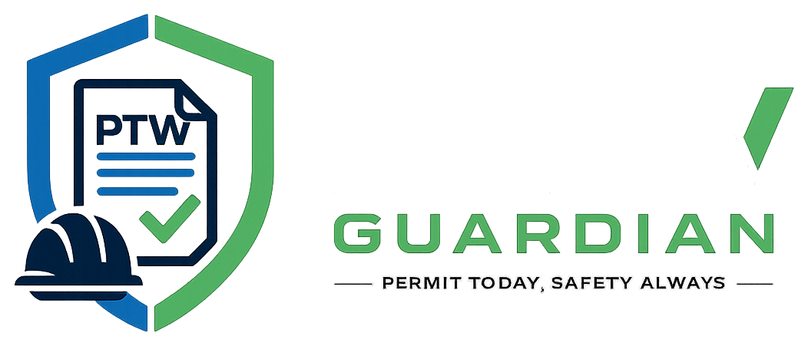
CLOUD MIGRATION HANDOVER PACK
PTW V1 Cloud Migration Handover Checklist
What to give the cloud/backend engineer, what must remain private, and how to confirm a complete transfer.
Project | Handover details
Application | PTW Guardian - Permit to Work Management System (PTW V1)
Source repository | https://github.com/UptimeProDev/projek-webapp-ptw
Primary stack | Node.js, Express, MySQL, HTML, CSS, and JavaScript
Prepared | 24 July 2026

Main rule Share source code through the ZIP or GitHub. Share database records, attachments, passwords, API keys, and cloud access separately through approved secure channels.

1. Purpose and Handover Outcome
This checklist supports the next project phase: moving PTW V1 from a local Windows/XAMPP environment to a cloud-hosted backend. It does not prescribe one cloud architecture. The receiving engineer should assess the application, select suitable managed services, migrate the required data, and verify every role and permit workflow.

2. Core Project Package
☐ Provide PTW V1.zip and confirm that it extracts without errors.
☐ Provide access to the GitHub repository and confirm the recipient can clone or download it.
☐ Provide the Project Documentation folder, including the user manual, setup guide, backend logic reference, and this checklist.
☐ Confirm the source handover version, Git branch, and commit identifier.
Code package The ZIP and repository are sufficient for reviewing and adapting the application code. They are not automatically sufficient to reproduce current database records, uploaded evidence, or private service credentials.

3. MySQL Database Export
Provide a database export only when the recipient must preserve existing organizations, users, permits, workers, audits, notifications, or other operational records. The application can create its schema for a clean installation, but it cannot reconstruct historical records that were never exported.

3.1 What to provide
- A dated SQL dump, for example: ptw-backup-2026-07-24.sql.
- The source database name and MySQL/MariaDB version.
- Whether the dump contains real, test, or demonstration data.
- Any known migration notes, data-cleaning requirements, or records that must not move to cloud.

3.2 Example export
Using XAMPP: open phpMyAdmin, select the PTW database, choose Export, select SQL format, and download the file. Command-line alternative: mysqldump -u root -p --routines --triggers ptw > ptw-backup.sql.
Sensitive data A database dump may contain names, emails, hashed passwords, permit history, safety records, and audit information. Do not commit it to a public repository or send it through an unsecured chat.

4. Uploaded Permit Files
Provide the uploads folder when the existing system contains permit attachments, supporting documents, MOS/JSA files, worker evidence, profile images, or other uploaded records that must remain available after migration.
☐ Copy the complete uploads folder without changing its internal filenames or directory structure.
☐ Scan the folder for malware and confirm its approximate size.
☐ Confirm which file types contain personal, safety, or confidential information.
☐ Transfer it through an encrypted drive, approved cloud share, or another controlled channel.
☐ Ask the cloud engineer to map the local upload logic to persistent cloud storage or object storage.
Important Do not assume that files stored on a temporary cloud application disk will survive restarts or redeployments. The cloud design should use persistent storage and keep database file references synchronized.

5. Environment Configuration
Provide .env.example as the configuration template. The recipient should create a new private .env or use the selected cloud provider's secret-management service. Never upload the working .env file to a public repository.
Configuration group | Examples | Handover action
Application | PORT and runtime settings | Confirm expected service port and production start command.
Database | DB_HOST, DB_PORT, DB_USER, DB_PASSWORD, DB_NAME | Recipient replaces local MySQL values with managed cloud database values.
Platform administrator | SUPERADMIN_EMAIL and SUPERADMIN_PASSWORD | Create new production credentials; do not reuse demonstration passwords.
Email | SMTP host, port, user, password, sender | Provide only through a secret manager or secure password channel.
SMS | Provider keys, sender ID, endpoint | Provide only if SMS delivery is required in production.
Never include Do not place real passwords, database credentials, SMTP passwords, SMS tokens, private keys, or cloud access keys inside this document.

6. SMTP and SMS Credentials
Email and SMS integrations are optional service dependencies. If production notifications are required, the recipient needs valid provider accounts and configuration. Credentials should be sent separately from the ZIP and GitHub link.

6.1 Secure transfer options
- Cloud secret manager or deployment-platform environment variables.
- Company password manager with access limited to the receiving engineer.
- Encrypted file or approved secure message with the password delivered through a different channel.
- Temporary credentials that are rotated immediately after deployment.

6.2 Information to record without exposing secrets
☐ Provider name and account owner.
☐ Sender email address, sender name, SMS sender ID, and approved domain.
☐ Required ports, encryption mode, regional endpoint, quotas, and rate limits.
☐ Who can reset or rotate the credentials.
☐ Test recipient to use during deployment verification.

7. Branding, Domain, and Cloud Account Details
Item | What to hand over
Logo and assets | Original logo files, favicon, approved colours, organization name, and any usage restrictions.
Domain | Selected domain/subdomain, DNS owner, registrar, and person authorized to approve DNS changes.
TLS/HTTPS | Confirm whether certificates are provider-managed or supplied by the organization.
Cloud account | Provider organization/account, billing owner, region restrictions, budget owner, and access approver.
Email domain | Approved sender domain and access needed for DNS verification records.
Support contacts | Technical owner, business owner, security/privacy contact, and emergency escalation contact.
Access control Invite the recipient using their own named account and the minimum role required. Do not share the cloud account owner's personal password or multi-factor authentication codes.

8. Cloud Provider Decision
The project owner should confirm the target cloud provider before implementation. If no provider has been selected, the receiving engineer should prepare options based on cost, managed MySQL availability, persistent file storage, region, backups, security, and maintenance responsibility.
☐ Selected provider: ______________________________________________
☐ Target region: _________________________________________________
☐ Monthly budget or limit: _________________________________________
☐ Managed MySQL service: _________________________________________
☐ Application hosting service: _____________________________________
☐ Object/persistent storage service: _________________________________
☐ Monitoring and backup service: __________________________________
☐ Person approving the architecture and cost: _________________________

9. Expected Cloud Migration Work
- Review the repository, documentation, current local runtime, schema initialization, and upload behavior.
- Design the production environment, network access, managed MySQL, persistent storage, HTTPS, secrets, backups, monitoring, and logging.
- Create a production configuration without copying local or demonstration passwords.
- Import the SQL dump when historical data must be preserved, then validate row counts and tenant relationships.
- Move attachments to persistent storage and confirm every database reference resolves correctly.
- Deploy the Node.js/Express application and configure the production domain.
- Test authentication, tenant isolation, role permissions, permit approval stages, worker assignment, Hold, Stop, Resume, timers, audit trails, final closure, notifications, and exports.
- Document the production architecture, deployment procedure, backup/restore procedure, monitoring, credential rotation, and support ownership.

10. Final Recipient Verification
☐ ZIP received and extracted.
☐ GitHub access confirmed.
☐ Documentation received.
☐ SQL dump received or formally marked not required.
☐ Uploads received or formally marked not required.
☐ .env.example received; no production secrets were committed to GitHub.
☐ SMTP/SMS requirements and secure credential channel agreed.
☐ Branding and domain ownership confirmed.
☐ Cloud provider, region, budget, and account access confirmed.
☐ Production acceptance tests and responsible approver agreed.
Handover sender: __________________________ Date: _______________
Recipient: _______________________________ Date: _______________
Cloud migration owner: ____________________ Target date: _________

11. Items That Should Not Be Placed in GitHub
- The working .env file or any secret-management export.
- SQL dumps containing personal, operational, or safety data.
- Uploaded permit evidence or worker identity documents.
- SMTP, SMS, cloud, database, domain, or registrar passwords and tokens.
- Private certificates, SSH keys, backup encryption keys, or multi-factor recovery codes.
- Production logs containing tokens, personal data, or confidential permit details.
Safe handover summary Send code and public configuration templates through ZIP/GitHub. Send operational data and attachments through protected storage. Send secrets through a secret manager or controlled password channel. Grant cloud access using named accounts with least privilege.

